Introduction to the Vula Sign-up Tool:

The Vula sign-up tool allows users to create meetings that members can sign-up for. The tool includes an attendance register for every activity as well as the ability to export meeting data for further analysis.

Contents

Part 1: Add the sign-up tool to your Vula site: 2

Part 2: Creating a Meeting 4

Add a meeting. 4

Meeting Details. 4

Basic information 4

Meeting times and frequency 5

Meeting type 6

Copy Meetings 7

View meetings 8

Attendance Register 9

Part 3: Student Sign-up 10

Part 4: Exporting Data 11

# Part 1: Add the sign-up tool to your Vula site:

The sign-up tool needs to be added to your Vula site before you can use it. Follow the instructions below to do so.

1. Navigate to the Site Setup tab

1. Navigate to the Manage Tools tab

1. Tick the checkbox for the Sign-up tool and then click *continue.*

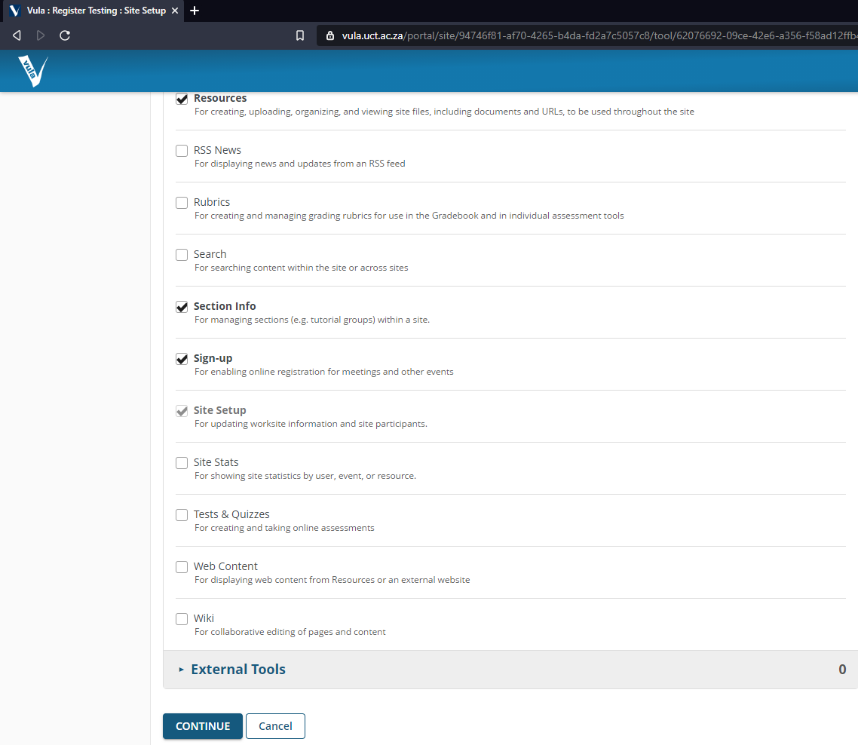

The sign-up tool should now appear in your Vula site navigation bar on the left. You can now move on to Part 2: Creating a Meeting.

# Part 2: Creating a Meeting

Once the sign-up tool has been added you can begin adding meetings for students to sign-up for.

## Add a meeting.

Click on the “add” button at the top of the sign-up tool to create a new meeting.

,

## Meeting Details.

Enter the relevant information regarding your meeting.

### Basic information

* Title
* Organizer – This should be the person who will be responsible for the activity.
* Location – This is crucial for contact tracing.
* Category – What type of activity is it? Practical/Tutorial/Hotseat etc.
* Description – Should you wish to clarify the purpose of the activity.

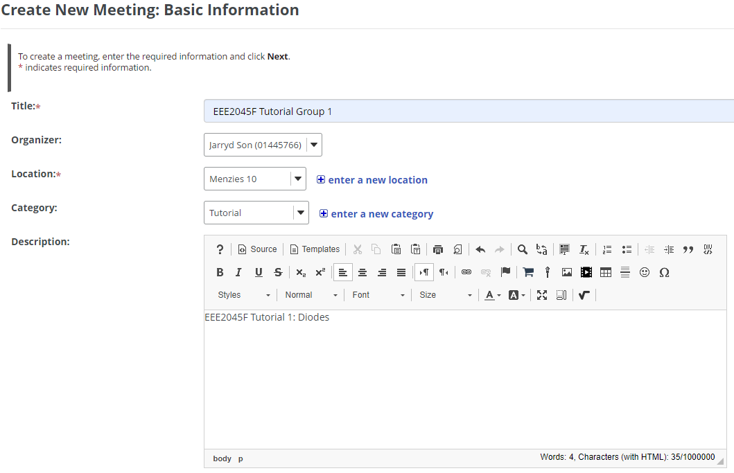

### Meeting times and frequency

Choose when your meetings take place. If they have a regular pattern they can be set as recurring meetings.

* The information at this stage is for an entire activity e.g. tutorial 1, prac 1. The meeting times can be broken up into smaller timeslots at a later stage if necessary.
* If it is a recurring meeting, then you should only indicate the start and end times for the first day of the activity. Then choose the appropriate frequency (daily/weekdays/weekly/bi-weekly) and what date the recurring meetings should end.
* You may also choose when to allow students access to sign-up by choosing dates for “Sign-up begins” and “Sign-ups ends”.

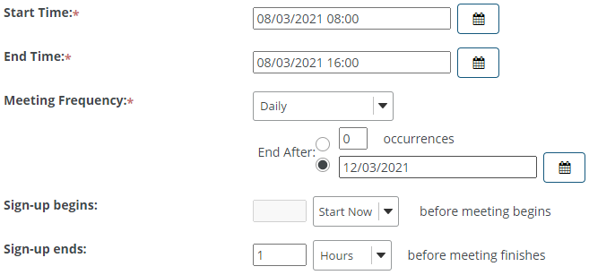

* Make sure you tick the “Attendance will be taken” checkbox so that Vula generates the attendance register for the activities.

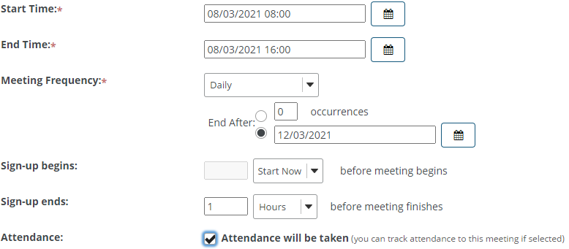

### Meeting type

Choose how timeslots are allocated for your activity.

* **Single slot** – if you do not need different timeslots for an activity. E.g., Tutorial session that all students attend at the same time. The “Start Time” and “End Time” specified earlier will control the single time slot in this instance.
* **Multiple timeslots** – if you need to offer multiple sessions for the same activity e.g. A practical might be offered three times in a day to accommodate different groups of students. It is still the same activity but requires alternate time slots.
  + Enter the information for multiple slots (# slots and # participants).

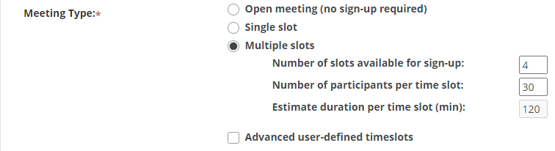

* + Vula will attempt to automatically create timeslots based on the number of slots available, but this will not be able to account for scheduled breaks and other irregular patterns.
    1. To customize the timeslots tick the Advanced user-defined timeslots checkbox. Then click “Create Timeslot(s)”.

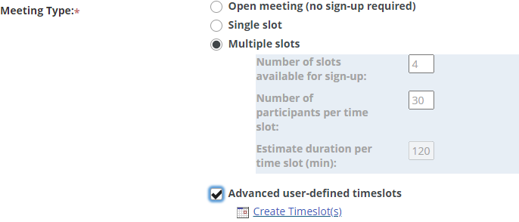

* + 1. You can now alter the times accordingly. For recurring meetings, you only need to enter the timeslots for the first day of the activity. Vula will automatically generate the rest of the timeslots according to the meeting frequency. Once you have set your times click “Continue”.

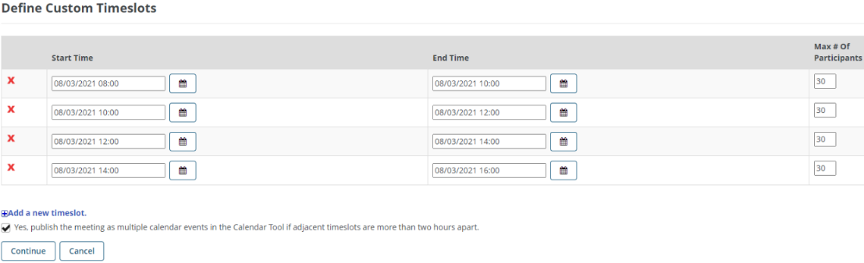

* If you are happy with the meeting details click “Next” at the bottom of page to view the meeting summary.
  + There are some additional default settings that you may change.
  + You can also pre-assign students to certain slots. It might be a good idea to pre-assign tutors/TAs/teaching staff who will be present in the activity (make sure to adjust the number of sign-up slots to account for this)
  + Once you are ready click “Publish” to post it to the Vula Site.

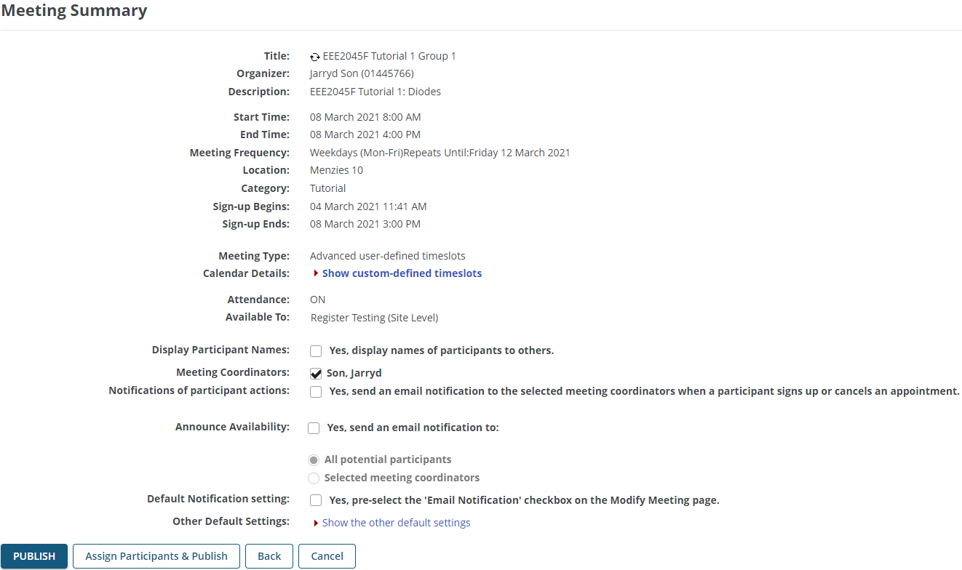

### Copy Meetings

You can also copy existing meetings to make the process quicker if the activities are similar

* View an existing meeting and click “Copy” at the top of the page.

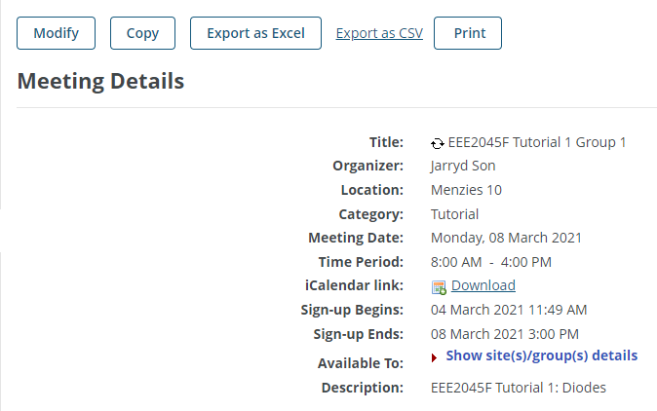

* + This is useful for managing multiple venues for the same activity. E.g. EEE2045F Tutorial 1 Group 2 might take place at the same time as Group 1, but in Menzies 9. You could copy the existing meeting and edit the location, while the timeslots would remain the same.
  + This can also be used for different activities that have the same timing. E.g. EEE2045F Tutorial 2 Group 1 might happen later in the semester. You could copy the meeting for tutorial 1, however new calendar details need to be captured (Vula does seem to allow editing of the “Start Time” and “End Time” on copied activities).

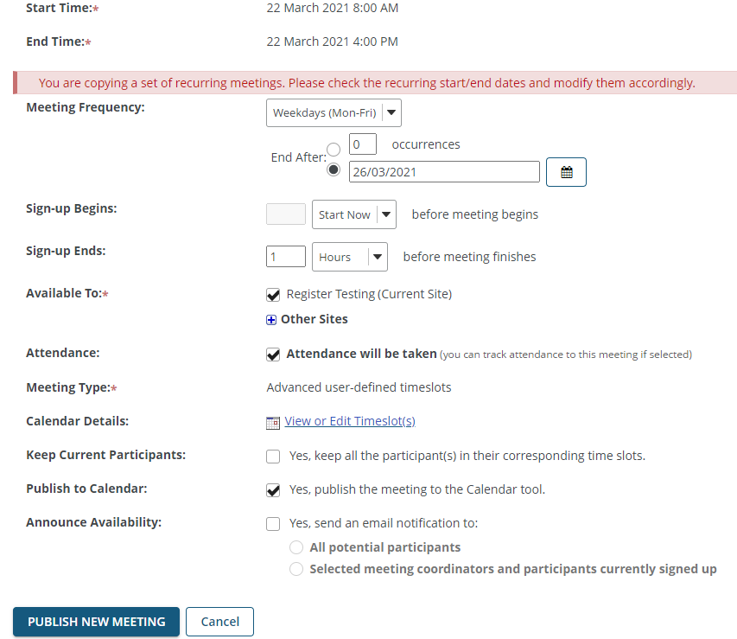

## View meetings

Once published the meeting will appear in the sign-up tool.

* Recurring meetings are collapsed by default.
* Click the ‘+’ sign to show expand a particular recurring meeting or tick the “Expand all recurring meetings” checkbox if you wish to show every meeting.

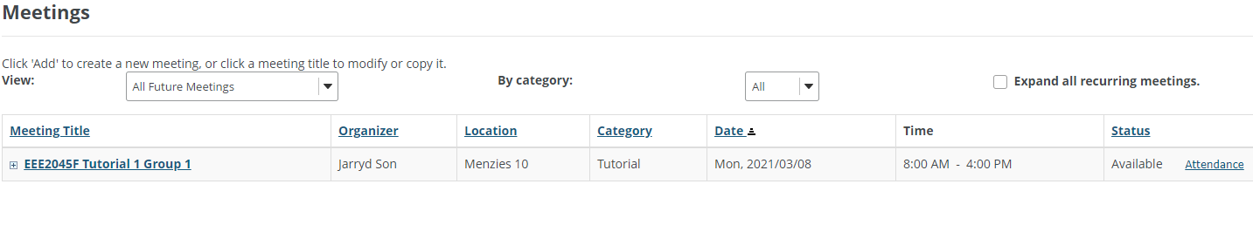

* Timeslots are only visible after selecting a specific meeting.

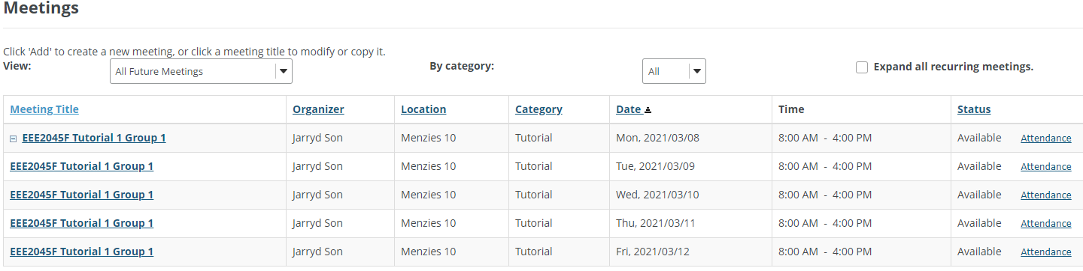

* Once you have selected a meeting you may manage participants for each timeslot

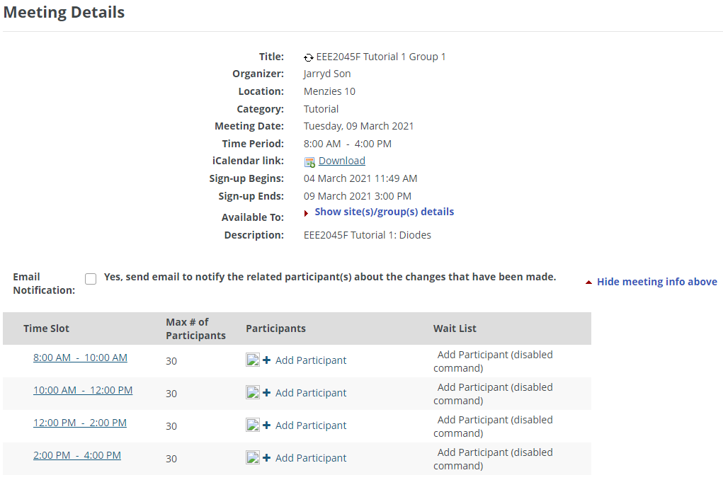

### Attendance Register

Certain members should be granted permissions to edit the attendance register.

* If you have permission to view and edit the attendance register you can click on the “Attendance” link for the timeslots you wish to record.



* The attendance register has checkboxes for the attendees signed-up for each timeslot.
  + The checkboxes must be ticked to confirm attendance.
  + Click the “Save” button to save the state of the attendance register.

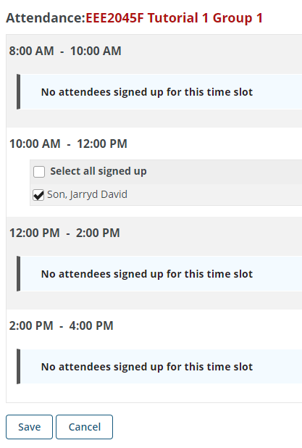

# Part 3: Student Sign-up

Once a meeting is added students will be view and sign-up for timeslots.

As an example, lets assume a student would like to sign up for EEE2045F Tutorial 1 Group 1 which is in Menzies 10 on Tuesdays at 10am.

1. They should click on the meeting corresponding to the desired day.

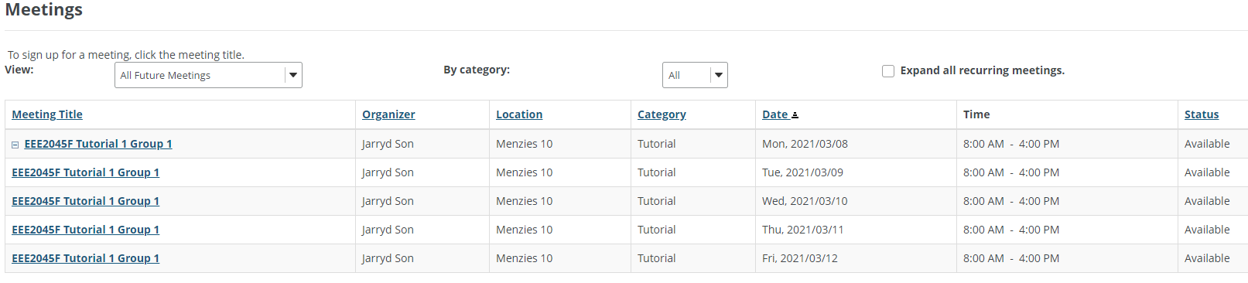

1. Then they should click the “Sign up” button to book their desired timeslot
   1. If the waiting list option is enabled students can be placed onto a waiting list and will be automatically put into the slot if space becomes available.

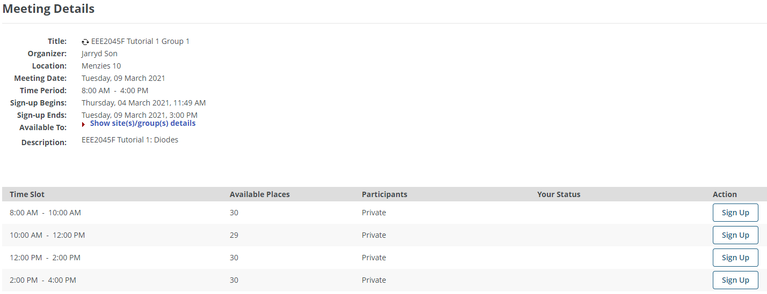

1. If they have signed up successfully the students should receive email notifications and calendar invites if those options are selected in the meeting settings

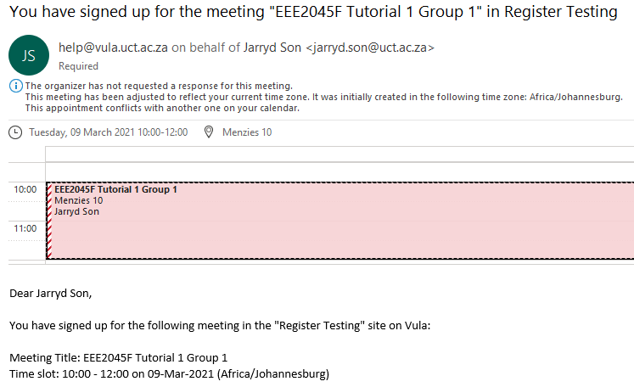

# Part 4: Data Handling

The sign-up data on Vula could be invaluable for assisting with efficient contact tracing in the event of a positive case being reported.

## Exporting data

Vula can export meeting data for easier analysis.

1. Click on the “Export” tab at the top of the sign-up tool.

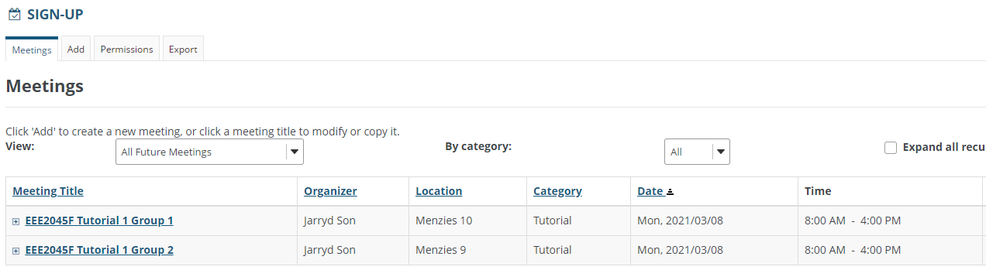

1. Choose the activities you wish to export by ticking the corresponding checkboxes then click “Export as Excel” for a detail breakdown of all exported activities. *The CSV export for this data is not very user-friendly.

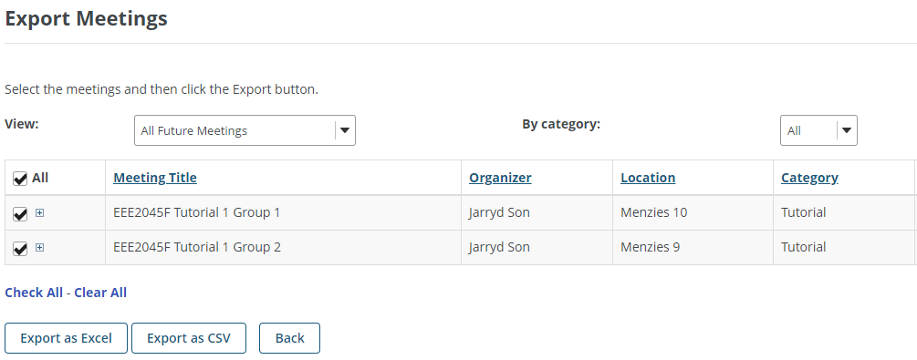

1. The exported data contains an Attendees Schedule sheet which contains all the important meeting data such as appointment times and locations (which together can be used to identify events for contact tracing).

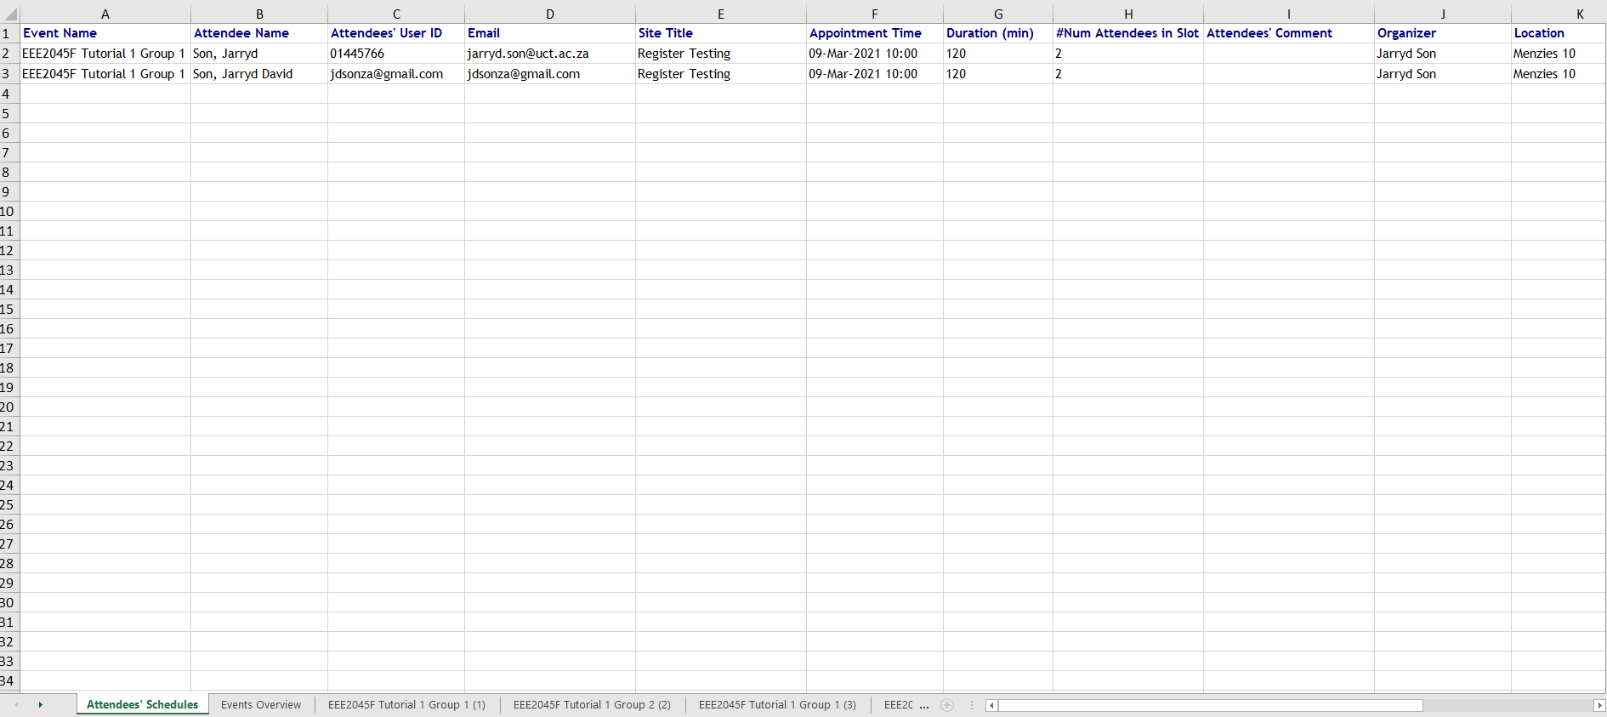

1. There is also an Events Overview that indicates basic event information

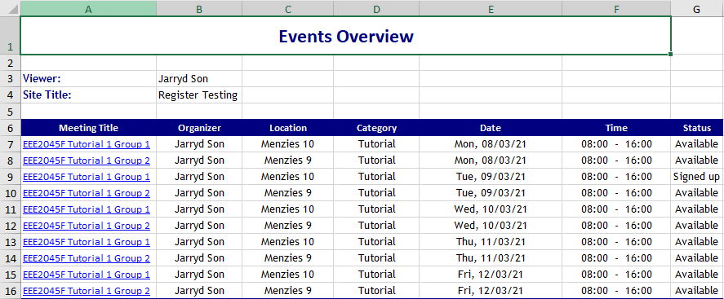

1. Then there are numerous tabs that provide details for each event

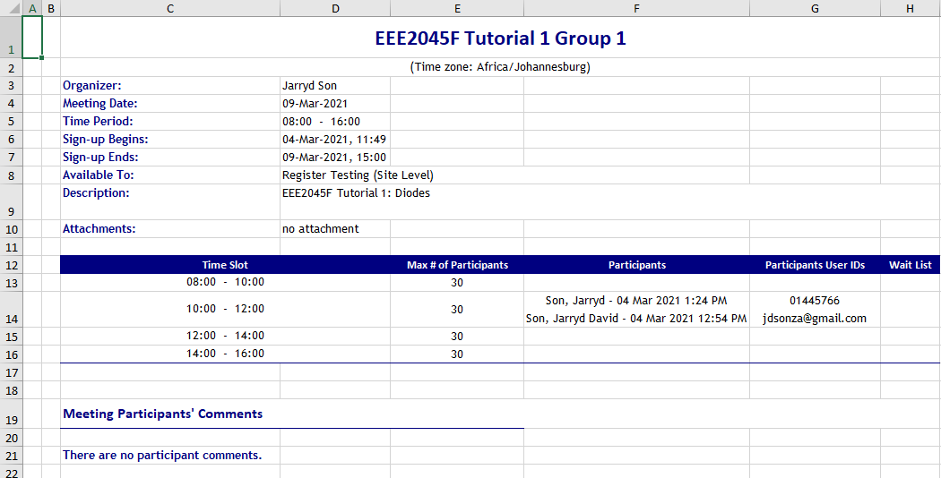

## Performing automated contact tracing with exported sign-up data

With the digitized attendance schedules, we can perform automated contact tracing. As an example, suppose a student was present in EEE2045F and EEE2046F activities. One could manually identify individuals who have been in contact with a probable/confirmed case, however this could be cumbersome with more activities, venues, courses and larger numbers of positive cases.

Here is a demonstration of a contact tracing tool that could ease the process :

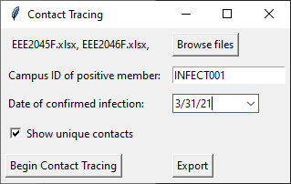

**6.**

**5**

**5.**

**5**

**4.**

**1.**

**2.**

**3.**

1. Click the "Browse Files" button and select all of the attendance schedule spreadsheets you wish to perform the contact tracing on.
2. Enter the Campus ID of the infected person (probable or confirmed)
3. Enter the date on which the infected person first started showing symptoms (or from the date of diagnosis for asymptomatic cases)
4. You may uncheck the "Show unique contacts" checkbox if you wish export all contact events.
5. Click "Begin contact tracing" to start the process.
6. Once the contact tracing process is complete you will be allowed to export the data. You may choose .xlsx, .csv or .pickle filetypes.
7. You can analyse the data further in spreadsheet tools such as Excel.

The exported data below shows unique individuals who have had contact with the infected person.

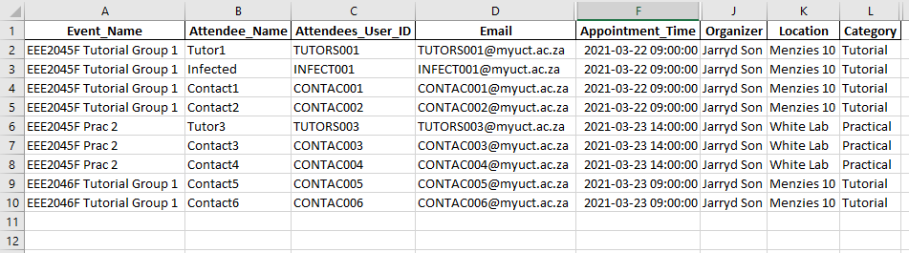

Please visit the Tracer github page (<https://github.com/jdsonza/tracer>) to download the tool and for up-to-date information regarding updates and changes.